BITS SCHOOL OF MANAGEMENT
Term , Block , 2026 - 27
Course Outline

Course Title: Route to Market Strategies

Faculty: Tarun Kushwaha

Dates: March 8th through March 19th

Contact Details: tkushwaha@gmail.com

Academic Associate:

Contact Details:

Office Hours:

Course Description:
Firms have many different routes to take to bring their products and services to the marketplace. These routes or channels are the inter-organizational systems and entities involved in making products and services available for consumption at the right place, time, and customer value proposition. This course explores the elements, design, and management of routes to markets including channel institutions/entities; market segmentation; selecting and incentivizing partners; managing channel relationships, power, and conflict. Emphasis will be placed on the strategic role of channels in achieving a firm's objectives.

Program Overview:
This course examines how firms design and manage routes to market—the channels through which products and services move from producers to end users—addressing the "Place" pillar of the 4Ps marketing framework. Effective channel design and management are central to ensuring a distribution system operates efficiently.

Marketing channels have transformed dramatically over the past two decades. Power has shifted from manufacturers to retailers, while digital channels—internet, smartphones, virtual reality, and AI—have pressured traditional brick-and-mortar retail. Physical presence remains essential for some businesses but serves as a differentiator in others, making multichannel and omnichannel capabilities critical to sustaining competitive advantage.

Manufacturers increasingly launch owned channels to strengthen control, deliver curated customer experiences, and improve margins, which has intensified conflicts among channel members whose roles continue to evolve. Multinational corporations entering emerging markets face additional challenges: highly fragmented channels, limited physical infrastructure, and constrained working capital. Meanwhile, capturing consumer insights through channel interactions has become a key source of competitive advantage.
This course explores these evolving dynamics, equipping marketers with the frameworks needed to design and manage distribution systems that respond to shifting channel power, digital disruption, and changing customer expectations. This course is envisioned to be at the intersection of three important business domains:
- Designing and Managing Routes to Markets (Vertical integration, Intensity, Conflict, Incentives, Power, and Relationship)
- Retailing (Customer Needs, Customer Journey, Channel Preferences, Multichannel, Omnichannel, Fulfillment)
- Digital Transformation (Disintermediation, Reintermediation, Tech Transformation, Customer Data, Platforms, Metamediaries, Gig-Economy)

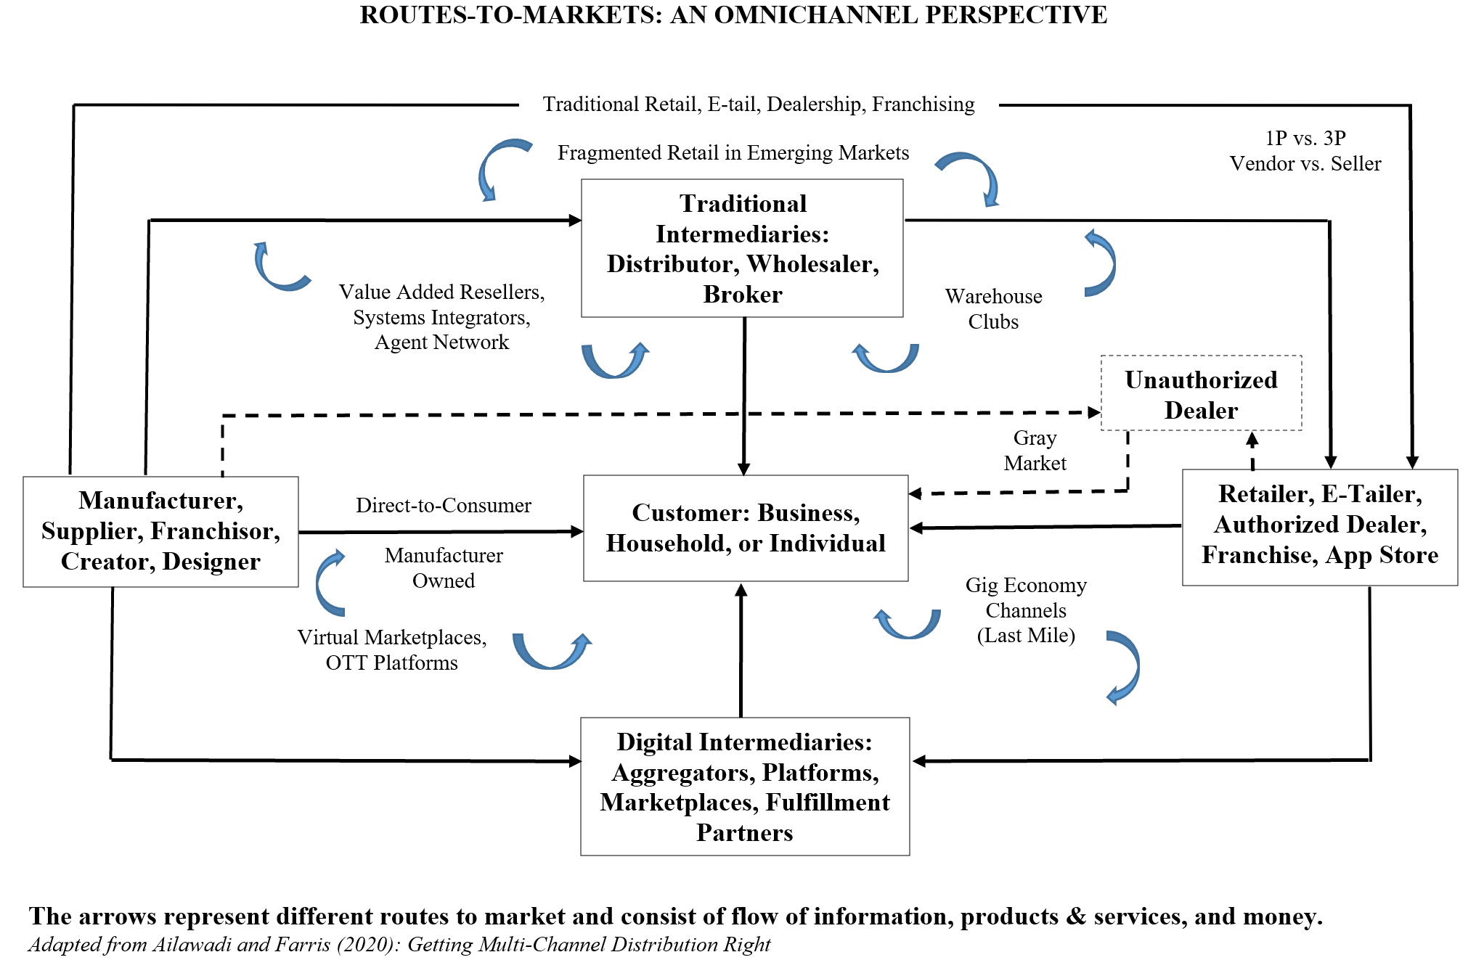

Mode of Delivery: In-person Face-to-Face

Face-to-face sessions with a variety of tools and teaching approaches. For some topics, I will rely on conventional lecturing. In those instances, I have prepared lecture notes which highlight the main points. Other topics are best covered in a more experiential fashion. Here, we will rely on analyses of actual company cases.

Interaction will occur through the regularly scheduled class meetings and through office hours. Substantive interaction will include direct instruction, facilitation of in-class discussions, and feedback on assignments.

Key Learnings for Participants:
It is important to point out that channel issues are usually complex. Supplier/channel relationships are inherently adversarial and complex and therefore less susceptible to facile analysis. The student will have to deal with “ambiguity” in solving channel problems. The future employers, ultimate customers and society need and seek students who have been challenged and can adequately deal with ambiguity in solving problems. The key learning objectives are:

- Articulate why routes to markets are a source of value creation for a firm and its customers.
- Apply channel frameworks to design and evaluate the effectiveness of channel strategies for a variety of products and services.
- Identify and analyze sources power and strategies for effective channel governance.
- Identify and apply attributes of route to market strategies including customer segmentation; allocation of channel functions and responsibilities; management of relationships and incentives.
- Using case analysis methodology, you will develop a toolkit to solve complex unstructured, and often intractable problems that are commonly faced by managers.

Key Takeaways:
The course is oriented towards the following career paths: Brand or Product Management, Retailing or E-tailing, Supply Chain Management, Consulting, General Management.

Course Materials: Hardcopy Coursepack with following readings + Class slides will be posted on course website
- Managing Consumer Touchpoints at Nissan Japan, By: Thales S. Teixeira, Nobuo Sato, Akiko Kanno, Publication Date: Sep 2015 (Revised February 09, 2020), Product Number: 516035-PDF-ENG
- Developing and Managing Channels of Distribution, By: V. Kasturi Rangan, Publication Date: Jun 2014 (Revised October 04, 2022), Product Number: 8149-PDF-ENG
- Tamul Plates Marketing: Channel Challenges for an Organic Product, By: Rajesh Aithal, Publication Date: Apr 2020, Product Number: W20303-PDF-ENG
- Eco7: Launching a New Motor Oil, By: John A. Quelch, Sunru Yong, Publication Date: Sep 2015, Product Number: 916507-PDF-ENG
- Grupo Boticario: Orchestrating a Customer Value-Centric Growth Strategy to Compete in Brazil's Beauty Market, By: Leandro Guissoni, Gilberto Sarfati, Ruth Costas, Publication Date: Jul 2025, Product Number: UV9307-PDF-ENG
- Juewei Food: Market Expansion Strategy, By: Juan Li, Yini Zheng, Jing Chen, Qing Zhang, Yi Wang, Publication Date: Sep 2025, Product Number: W44926-PDF-ENG
- Managing Multi- and Omni-Channel Distribution: Metrics and Research, Journal of Retailing, 2017, 93(1)
- PolyMax Pipes: Loyalty Challenges and Strategic Choices, By: Tata Sai Vijay, Subimal Sarmah, Shiwangi Singh, Publication Date: May 2026, Product Number: W48150-PDF-ENG
- Unilever Ethiopia's Shakti Initiative: Building a Rural Sales Channel, By: Ted London, Publication Date: Apr 19, 2022, Product Number: W01C42-PDF-ENG
- Rolex SA, By: Doug J. Chung, Publication Date: Feb 2021, Product Number: 521034-PDF-ENG
- Arcelik: From a Dealer Network to an Omnichannel Experience, By: Ayelet Israeli, Fares Khrais, Publication Date: Jan 2021 (Revised March 16, 2022), Product Number: 521067-PDF-ENG
Assessment Parameters:
Your overall performance in the course will be evaluated on the following basis:
- Three (choose out of Four) Case analyses presentations (Team) 45%
- Final Case Analysis (Individual) 35%
- Class Participation (Individual) 20%
100%
Group Size: The group size for group exercises and final projects will be no more than 5 per group. Students pick their own groups.

POLICY:

Class Policies
We will start classes on time.
If you are late, the instructor has the choice of not allowing you to attend or creating creative punishments for tardiness.
Please ensure that your name tag is displayed during every class. Failure to do so may affect your class participation grade/attendance.
Section swaps will be permitted only with the prior approval of the instructor.

Attendance Policy
The attendance policy as laid out by the Programme Office applies. Please refer to your student handbook for details.

Honour Code
BITSoM takes the honour code seriously, and so should you. The student handbook contains details on the honour code policy at BITSoM. You are expected to abide by an honour code and follow a culture of honesty. Please ensure that you read the relevant section(s) in the handbook. Feel free to ask us in case you have any questions.

Coding scheme for all course work:

Code | Nature of Course work Discussion |  | Nature of Reference Material
Code | General Discussions | Specific Discussions | External Material | Case/Problem Solutions
AC-I | Not Allowed | Not Allowed | Not Allowed | Not Allowed
AC-IIa | Allowed | Not Allowed | Not Allowed | Not Allowed
AC-IIb | Not Allowed | Not Allowed | Allowed | Not Allowed
AC-IIIa | Allowed | Allowed | Not Allowed | Not Allowed
AC-IIIb | Allowed | Not Allowed | Allowed | Not Allowed
AC-IIIc | Not Allowed | Not Allowed | Allowed | Allowed
AC-IV | Allowed | Allowed | Allowed | Not Allowed
AC-V | Allowed | Allowed | Allowed | Allowed

Component | Honor Code
Class Participation | AC-V
Short group exercises and presentations | AC-IV
Online simulation | AC-I
Final Project and Presentation | AC-IIb

Technology Policy
- You are welcome to use a laptop or tablet for only note-taking purposes. However, in the discussion of cases you are not allowed to use any screens in the classroom.
- Please read the AI policy very carefully to know your responsibilities.
- Please turn off and put away cell phones.
- Please don’t take photos during the lecture.

Generative AI Use Policy
Students may use generative AI tools (e.g., ChatGPT, Claude, Gemini, Copilot) for brainstorming, editing, concept clarification, data analysis, coding support, etc. However, all submitted work must reflect the student's own analysis, judgment, and interpretation.

Students are responsible for verifying the accuracy of AI-generated content and must disclose any AI usage in their submissions. Undisclosed AI-generated work, use of AI during closed-book assessments, fabrication of sources, or delegating substantial academic work to AI constitutes an Honor Code violation.

Students are not allowed to upload any copyrighted material to AI tools, including assigned cases, readings, and class slides. It is not only violation of copyrights, but also violation of the Honor Code.

Mandatory Disclosure Statement: All submissions using AI must include this statement in the appendix or footnotes:
"I used [AI Tool Name] for [specific purpose: e.g., brainstorming, editing, data analysis]. The AI contributed [X% estimate] to this work. All ideas, analysis, and final conclusions are my own. I verified all AI-generated content for accuracy."

Key Success Factors
- Prepare for each class meeting, complete the reading(s), which is the foundational material.
- My lectures may cover more and different material from the assigned reading(s) for the day.
- For the cases, make sure that you have read and thoroughly processed the case beforehand, and be prepared to offer (a) your assessment of the problem(s) faced by the focal company, and (b) potential solutions.
- Be prepared to share your experiences with the class and expect to learn from your classmates. Recognize that much of the learning will take place in class.
- Make sure to take notes, both during the lectures and the case discussions.
- There is no assigned textbook for the case. However, if you take detailed notes from lectures and integrate learnings from case, you will have rich content to refer to when needed.
- Look for connections, both among the readings/lectures and cases, and between the different cases. Every reading and case has been assigned with a particular learning goal in mind, and each one appears at a certain point in the course for a specific reason.

Session Schedule
 | Date | Topic | Reading (Prior to Class) | Deliverable
Customer Needs and Channel Functions | March 8th | - Introduction to Course
Customer Needs and Channel Functions | March 8th | - Mapping Customer Journey  - Benefits Customers Desire  - Customer Segments  - Organizational Buying
Customer Needs and Channel Functions | March 8th | CASE (Customer Needs) | Managing Customer Touchpoints at Nissan Japan (REQUIRED)
Customer Needs and Channel Functions | March 9th | - What is a Channel?  - Channel Functions  - Channel Institutions | Developing and Managing Channels of Distribution, Pages 1-12 (REQUIRED)
Customer Needs and Channel Functions | March 9th | CASE (Roles of Channel Members) | Tamul Plates (REQUIRED)
Channel Design | March 10th | - Vertical Integration  - Direct to Consumer  - Incentives  - Double Marginalization | Developing and Managing Channels of Distribution, Pages 19-24 (REQUIRED)
Channel Design | March 10th | CASE (Incentives, Control, Customer Experience) | Eco 7: Launching a New Motor Oil (REQUIRED) | Team Submission #1
Channel Design | March 11th | - Distribution Intensity  - Channel Conflict  - Single vs. Multichannel  - Intrabrand Competition | Developing and Managing Channels of Distribution, Pages 13-18 and 24-27 (REQUIRED)
Channel Design | March 11th | CASE (Conflict, Multichannel) | Grupo Boticario: Orchestrating a Customer Value (REQUIRED)
Channel Design | March 12th | - Omnichannel  - Redefining the role of store  - B&M location still matters  - Role of technology in-store
Channel Design | March 12th | CASE (Omnichannel) | Juewei Food: Market Expansion Strategy (REQUIRED) | Team Submission #2
Channel Management | March 15th | - Relationships  - Relational Governance  - Opportunism  - Safeguarding Interests  - Franchising  - Channel Metrics | Managing Multi- and Omni-Channel Distribution: Metrics and Research, Journal of Retailing, 2017, 93(1) (REQURIED)
Channel Management | March 16th | - Power  - Brand vs. Channel Power  - Private Label Revolution  - 1P vs. 3P
Channel Management | March 16th | CASE (Brand vs. Channel Power) | Polymax Pipes: Loyalty Challenges and Strategic Choices (REQUIRED) | Team Submission #3
Channel Management | March 17th | - Route to Market  - Wholesalers, Distributors  - Fragmentation
Channel Management | March 17th | CASE (Multi-tiered Systems) | Unilever Ethiopia (REQUIRED)
Channel Management | March 18th | - Route to Market  - Gray Market  - Unauthorized Distribution
Channel Management | March 18th | CASE (Gray Market) | Rolex SA (REQUIRED) | Team Submission #4
Channel Management | March 19th | - Route to Market  - Metamediaries  - Platforms  - Virtual Marketplaces  - Course Wrap Up |  | Final Individual Case Submission Due Midnight: Arcelik

